**Task#1**

#include<stdio.h>

int main()

{

int age;

printf("enter your age\n");

scanf("%d",&age);

if (age>=18)

{

printf("you are eligible to vote\n");

}

else

{

printf("you are not eligible to vote\n");

}

return 0;

}

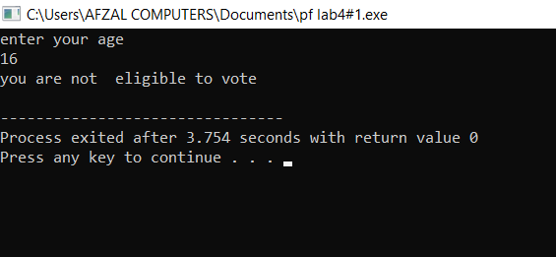

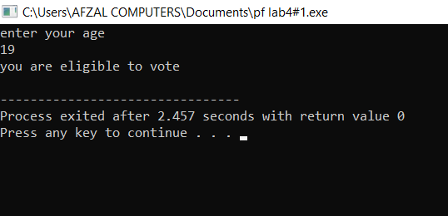

**Task#2**

#include<stdio.h>

int main()

{

int num;

printf("enter a number\n");

scanf("%d",&num);

if (num%2==0)

{

printf("it is an even number\n");

}

else

{

printf("it is an odd number\n");

}

return 0;

}

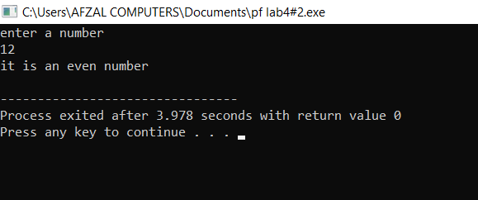

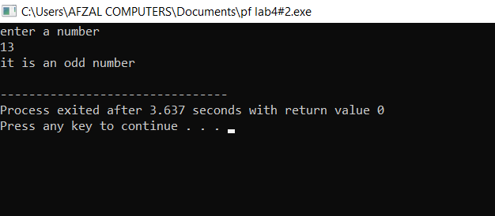

**Task#3**

#include<stdio.h>

int main()

{

int num1,num2,num3;

printf("enter num1\n");

scanf("%d",&num1);

printf("enter num2\n");

scanf("%d",&num2);

printf("enter num3\n");

scanf("%d",&num3);

if (num1>num2)

{

printf("%d is the greatest number",num1);

}

else if (num2>num3)

{

printf("%d is the greatest number",num2);

}

else

{

printf("%d is the greatest number",num3);

}

return 0;

}